Ground-Fault Circuit Interrupter
The ground-fault circuit interrupter (GFCI) is a fast-acting circuit breaker. It senses small imbalances in the circuit caused that current leakage to the ground creates and, in a fraction of a second, shuts off the electricity. The GFCI continually matches the amount of current going to an electrical device against the amount of current returning from the device along the electrical path. Whenever the amount “going” differs from the amount “returning” by approximately 5 milliamps, the GFCI interrupts the electric power within as little as 1/40 of a second.

Employer’s Responsibility
MIOSHA has developed ground-fault protection rules and regulations that are necessary and appropriate for employee safety and health. According to MIOSHA, an employer is responsible for providing either:
- ground-fault circuit interrupters on construction sites for receptacle outlets in use and not part of the permanent wiring of the building or structure; or
- a scheduled and documented equipment grounding conductor program on construction sites. The program should cover all cord sets and all receptacles that are not part of a building’s or structure’s permanent wiring. It should also cover any equipment connected by cord and plug that are available for use or in use by employees.

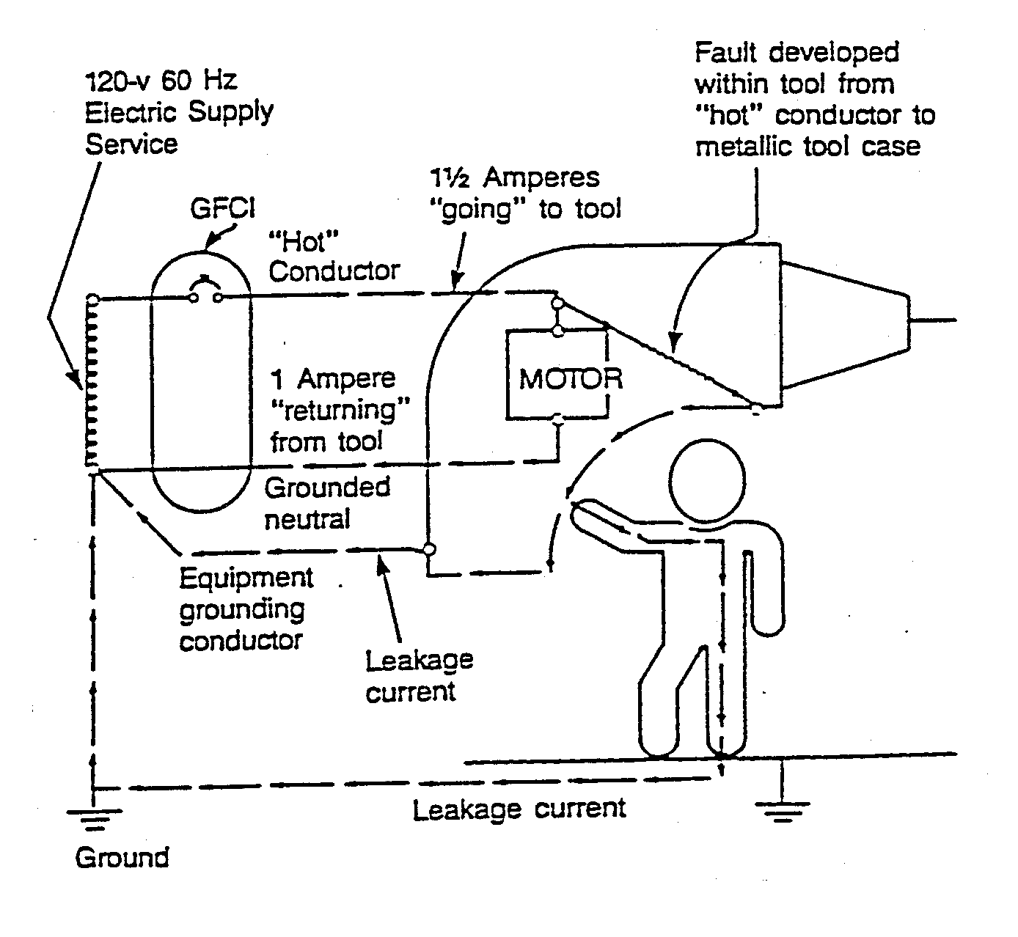

Insulation and Grounding
Insulation and grounding are two recognized means of preventing injury during electrical equipment operation. Conductor insulation usually takes the form of non-conductive material such as plastic around the conductor. Grounding may be achieved through the use of a direct connection to a known ground such as a metal cold water pipe.
The enclosure around a motor or the metal box that contains electrical switches, circuit breakers and controls should protect the equipment from dirt and moisture. In addition, such housings also prevent accidental contact with exposed wiring. However, there is a hazard associated with housings and enclosures. An internal equipment malfunction, such as deteriorated insulation, may create an electrical shock hazard.
To eliminate the hazard, many metal enclosures are connected to a ground. If a “hot” wire contacts a grounded enclosure, the resulting ground fault will normally trip a circuit breaker or blow a fuse. The usual method of grounding metal enclosures and containers is to connect them with an equipment grounding conductor, to a ground. The same method is used for most portable electric tools and appliances. There is one disadvantage to grounding. A break in the grounding system may occur without the user’s knowledge.
Hard use on the job or age may damage insulation. If the damage exposes the conductors, hazards of shocks, burns and fire will exist. Double insulation may afford additional protection on the live parts of a tool. However, it does not protect against defective cords and plugs or against heavy moisture conditions.
The use of a ground-fault circuit interrupter (GFCI) is one method to overcome grounding and insulation deficiencies.
There are two classes of GFCIs - Class A and Class B. The Class A GFCI trips at not more than 5 mA. The Class A GFCI is used where personal protection against ground fault is required or desired.
The Class B GFCI trips when the current exceeds 20 mA. The latter is only used with swimming pool underwater lighting fixtures that were installed prior to local adoption of the 1965 edition of the NEC.

Portable Tool Hazards
The common use of portable tools frequently increases the need for flexible cords. Improperly using and maintaining the following can create hazards: cords, cord connectors, receptacles as well as cord and plug connected equipment.
Generally, flexible cords are more vulnerable to damage than fixed wiring because they are exposed, flexible, and unsecured. In addition, flexible cord conductors are finely stranded for flexibility. As a result, the strands of one conductor may loosen from under terminal screws and touch another conductor, especially if the cord is subject to stress or strain. It is very important to connect flexible cords to devices and fittings in a manner that prevents tension at joints and terminal screws.
Normal use, door or window edges, staples or fastenings, abrasion from adjacent materials, or aging may damage a flexible cord. Exposed electrical conductors pose a danger of shocks, burns, or fire.
A wet cord connector can cause hazardous leakage to the equipment-grounding conductor. The leakage can also harm individuals who pick up that connector if they also provide a path to ground. Such leakage is not limited to the face of the connector but also develops at any wet portion of it.
If the leakage current of tools is below 1 ampere and the ground conductor has a low resistance, a person should feel no shock. However, an increase in the resistance of the equipment-grounding conductor also causes an increase in the current through the body. If the resistance of the equipment ground conductor is significantly greater than 1 ohm, tools with even a small leakage become hazardous.
Refer to MIOSHA Part 17, R 408.41721 (OSHA 1926.04) for additional information on ground-fault circuit interrupters.

